NAME: TEJASWINI SACHIN SHEWALE

ROLL NO.:37

SUBJECT:OOP

# Practical No.:01

Implement a class Complex which represents the Complex Number data type. Implement the following

1. Constructor (including a default constructor which creates the complex number 0+0i).
2. Overload operator+ to add two complex numbers.
3. Overload operator* to multiply two complex numbers.
4. Overload operators << and >> to print and read Complex Numbers

Code:

# include<iostream> using namespace std;

class Complex //decaring Class Complex

{

double real; double img;

public:

Complex(); // Default Constructor friend istream & operator >> (istream &, Complex &); // Input friend ostream & operator << (ostream &, const Complex &); // Output

Complex operator + (Complex); // Addition

Complex operator * (Complex); // Multiplication

};

Complex::Complex() // Default Constructor

{

real = 0; img = 0;

} istream & operator >> (istream &, Complex & i)

{ cin >> i.real >> i.img;

return cin;

}

ostream & operator << (ostream &, const Complex & d)

{

cout << d.real << " + " << d.img << "i" << endl; return cout;

}

Complex Complex::operator + (Complex c1) // Overloading + operator

{

Complex temp;

temp.real = real + c1.real; temp.img = img + c1.img; return temp;

}

Complex Complex::operator * (Complex c2) // Overloading * Operator

{

Complex tmp;

tmp.real = real * c2.real - img * c2.img; tmp.img = real * c2.img + img * c2.real; return tmp;

}

int main() { Complex C1, C2, C3, C4;

int flag = 1; char b; while (flag == 1)

{

cout << "Enter Real and Imaginary part of the Complex Number 1 : \n"; cin >> C1; cout << "Enter Real and Imaginary part of the Complex Number 2 : \n"; cin >> C2;

int f = 1; while (f == 1)

{

cout << "Complex Number 1 : " << C1 << endl; cout << "Complex Number 2 : " << C2 << endl; cout << "**********MENU**********" << endl; cout << "1. Addition of Complex Numbers" << endl; cout << "2. Multiplication of Complex Numbers" << endl; cout << "3. Exit\n"; int a;

cout << "Enter your choice from above MENU (1 to 3) : "; cin >> a; if (a == 1)

{

C3 = C1+C2; cout << "Addition : " << C3 << endl; cout << "Do you wan to perform another operation (y/n) : \n";

cin >> b; if (b == 'y' || b == 'Y')

{

f=1;

} else

{

cout << "Thanks for using this program!!\n"; flag=0; f=0;

}

} else if (a == 2)

{

C4 = C1 * C2; cout << "Multiplication : " << C4 << endl; cout << "Do you wan to perform another operation (y/n) : \n";

cin >> b; if (b == 'y' || b == 'Y')

{ f=1;

} else

{

cout << "Thanks for using this program!!\n"; flag=0; f=0;

}

} else

{

cout << "Thanks for using this program!!\n"; flag=0;

f=0; } } } return 0;

}

Output:

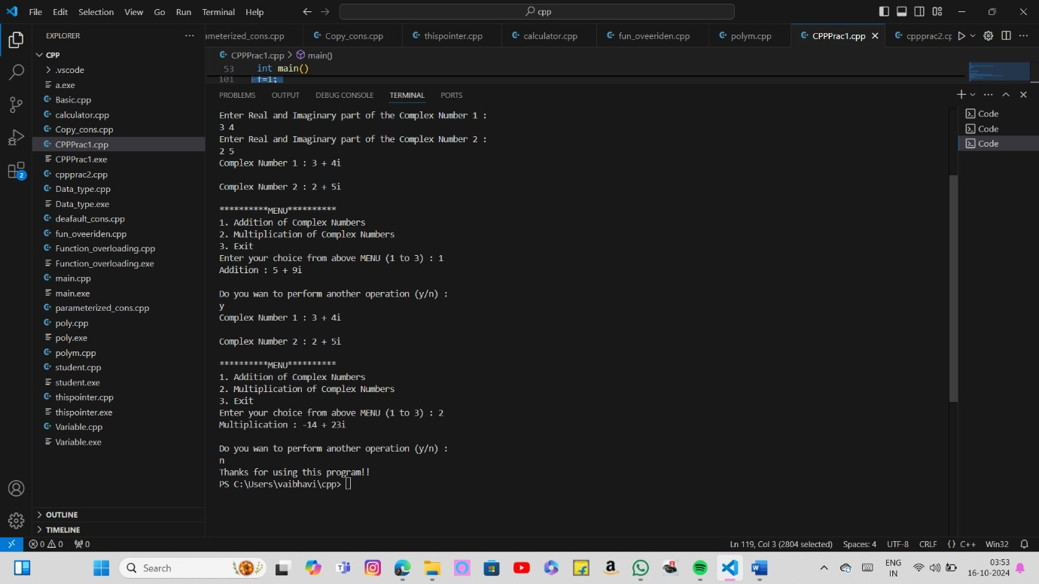

NAME: TEJASWINI SACHIN SHEWALE

ROLL NO.:37

SUBJECT:OOP

# Practical No.:02

Experiment Number 2 : Develop a program in C++ to create a database of student’s information system containing the following information: Name, Roll number, Class, Division, Date of Birth, Blood group, Contactaddress, Telephone number, Driving license no. and other. Construct the database with suitable member functions. Make use of constructor, default constructor, copy constructor, destructor, static member functions, friend class, this pointer, inline code and dynamic memory allocation operators-new and delete as well as exception handling.

code:

#include<iostream> #include<string.h> using namespace std; class Data

{

string address; long int *telephone; long int *dl_no; public:

Data(); ~Data(); void input_student_data(); void display_student_data(); friend class Student;

};

class Student

{

string Name;

int Roll; string Class; char *Div; string dob; char *bg; static int count; public:

Student(); ~Student(); static int get_count()

{

return count;

}

void input_data(Data *); void display_data(Data *);

};

Data::Data()

{

address = " "; telephone = new long; dl_no = new long;

}

Data::~Data()

{

delete telephone; delete dl_no;

}

void Data::input_student_data()

{

cout<<"Contact Address : "; cin.ignore(); getline(cin,address); cout<<"Telephone Number : "; cin>>*telephone; cout<<"Driving License Number : "; cin>>*dl_no;

}

void Data::display_student_data()

{

cout<<"Contact Address : "<<address<<endl; cout<<"Telephone Number : "<<*telephone<<endl; cout<<"Driving License Number : "<<*dl_no<<endl;

}

Student::Student()

{

Name = " ";

Roll = 0;

Class = " "; Div = new char; dob = "dd/mm/yyyy"; bg = new char[5];

}

Student::~Student()

{

delete Div; delete[] bg;

}

inline void Student::input_data(Data *stud1)

{

cout<<"Name : ";

cin.ignore(); getline(cin,Name); cout<<"Roll Number : "; cin>>Roll; cout<<"Class : "; cin.ignore(); getline(cin,Class); cout<<"Division : "; cin>>Div; cout<<"Date of Birth : "; cin.ignore(); getline(cin,dob); cout<<"Blood Group : "; cin>>bg; stud1->input_student_data(); count++;

}

inline void Student::display_data(Data *stud2)

{

cout<<"Name : "<<Name<<endl; cout<<"Roll Number : "<<Roll<<endl; cout<<"Class : "<<Class<<endl; cout<<"Division : "<<Div<<endl; cout<<"Date of Birth : "<<dob<<endl; cout<<"Blood Group : "<<bg<<endl; stud2->display_student_data();

cout<<"----------------------------------------------------------------------\n";

}

int Student::count; int main()

{

Student *st1[100]; Data *st2[100];

int a; int s=0; char ch; cout<<"--------------------MENU--------------------\n";

cout<<"1. New Student\n"; cout<<"2. View Database\n"; cout<<"Enter your choice : "<<endl; cin>>a; if(a==1)

{

do

{

st1[s] = new Student; st2[s] = new Data; cout<<"Enter the details of student "<<s+1<<" : "<<endl; st1[s]->input_data(st2[s]); s++; cout<<"Do you want to create a new student (y/n): "; cin>>ch;

}while(ch=='y' || ch=='Y');

}

else if(a==2)

{

cout<<"**************************StudentDatabase****************************"<<endl;

for(int i=0;i<s;i++)

{

st1[i]->display_data(st2[i]);

}

}

else

cout<<"WRONG CHOICE\n"; cout<<"Total Number of Students : "<<Student::get_count()<<endl;

return 0;

}

Output:

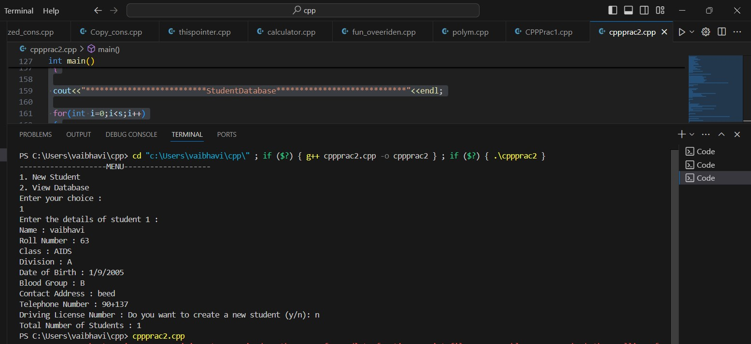

NAME: TEJASWINI SACHIN SHEWALE

ROLL NO.:37

SUBJECT:OOP

# Practical No.:03

Imagine a publishing company which does marketing for book and audiocassette versions. Create a class publication that stores the title (a string) and price (type float) of a publication.From this class derive two classes: book, which adds a page count(type int), and tape, which adds a playing time in minutes(type float). Write a program that instantiates the book and tape classes, allows user to enter data and displays the data members.If an exception is caught, replace all the data member values with zero values.

Code:

# include<iostream> # include<stdio.h> using namespace std; class publication

{

private: string title; float price; public: void add()

{

cout << "\nEnter the Publication information : " << endl; cout << "Enter Title of the Publication : "; cin.ignore(); getline(cin, title); cout << "Enter Price of Publication : "; cin >> price;

}

void display()

{

cout << "\n--------------------------------------------------";

cout << "\nTitle of Publication : " << title; cout << "\nPublication Price : " << price;

} };

class book : public publication

{

private: int page_count;

public: void add_book()

{ try

{

add(); cout << "Enter Page Count of Book : "; cin >> page_count; if (page_count <= 0)

{

throw page_count;

}

}

catch(...)

{

cout << "\nInvalid Page Count!!!"; page_count = 0;

}

}

void display_book()

{

display(); cout << "\nPage Count : " << page_count;

cout << "\n--------------------------------------------------\n";

} };

class tape : public publication

{

private:

float play_time; public: void add_tape()

{ try

{

add(); cout << "Enter Play Duration of the Tape : "; cin >> play_time; if (play_time <= 0) throw play_time;

}

catch(...)

{

cout << "\nInvalid Play Time!!!"; play_time = 0;

}

}

void display_tape()

{

display(); cout << "\nPlay Time : " << play_time << " min";

cout << "\n--------------------------------------------------\n"; } };

int main()

{

book b1[10]; tape t1[10]; int ch, b_count = 0, t_count = 0; do

{

cout << "\n* * * * * PUBLICATION DATABASE SYSTEM * * * * *";

cout << "\n--------------------MENU-----------------------"; cout << "\n1. Add Information to Books"; cout << "\n2. Add Information to Tapes"; cout << "\n3. Display Books Information"; cout << "\n4. Display Tapes Information"; cout << "\n5. Exit"; cout << "\n\nEnter your choice : "; cin >> ch; switch(ch)

{

case 1:

b1[b_count].add_book(); b_count ++; break; case 2: t1[t_count].add_tape(); t_count ++; break; case 3:

cout << "\n* * * * BOOK PUBLICATION DATABASE SYSTEM * * * *"; for (int j=0;j < b_count;j++)

{

b1[j].display_book();

}

break; case 4:

cout << "\n* * * * TAPE PUBLICATION DATABASE SYSTEM * * * *"; for (int j=0;j < t_count;j++)

{

t1[j].display_tape();

}

break; case 5: exit(0);

}

}while (ch != 5); return 0;

}

Output:

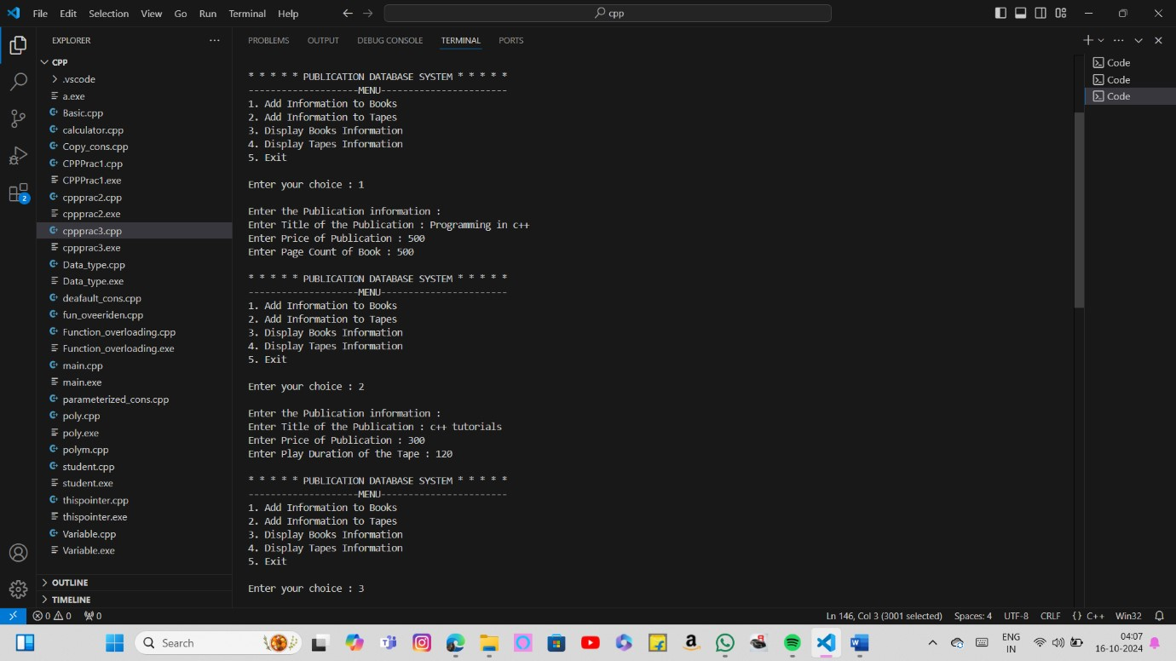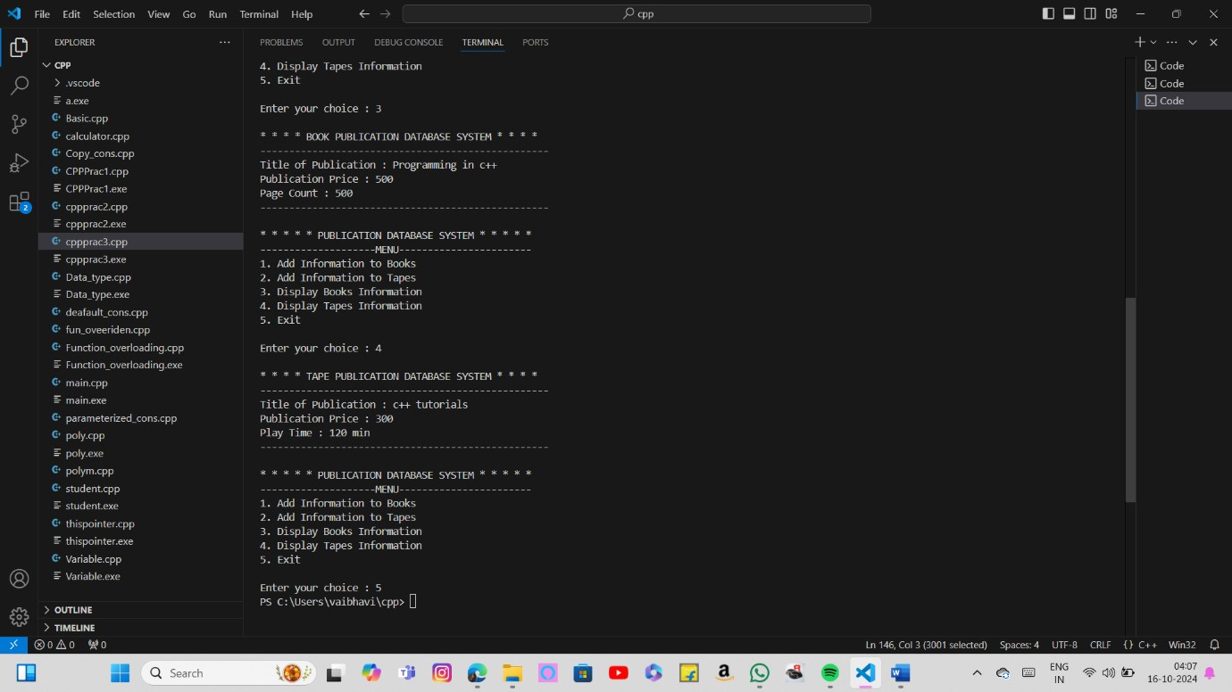

NAME: TEJASWINI SACHIN SHEWALE

ROLL NO.:37

SUBJECT:OOP

# Practical No.:04

Write a C++ program that creates an output file, writes information to it, closes the file, open it again as an input file and read the information from the file.

Code:

#include<iostream> #include<fstream> using namespace std; class Employee

{

string Name;

int ID; double salary; public:

void accept()

{

cout<<"\n Name : "; cin.ignore();

getline(cin,Name); cout<<"\n Id : "; cin>>ID; cout<<"\n Salary : "; cin>>salary;

}

void display()

{

cout<<"\n Name : "<<Name;

cout<<"\n Id : "<<ID;

cout<<"\n Salary : "<<salary<<endl;

} };

int main()

{

Employee o[5]; fstream f;

int i,n;

f.open("demo.txt"); cout<<"\n Enter the number of employees you want to store : "; cin>>n; for(i=0;i<n;i++)

{

cout<<"\n Enter information of Employee "<<i+1<<"\n"; o[i].accept();

f.write((char*)&o[i],sizeof o[i]);

}

f.close();

f.open("demo.txt",ios::in); cout<<"\n Information of Employees is as follows : \n"; for(i=0;i<n;i++)

{

cout<<"\nEmployee "<<i+1<<"\n";

f.write((char*)&o[i],sizeof o[i]); o[i].display();

}

f.close(); return 0;

}

Output:

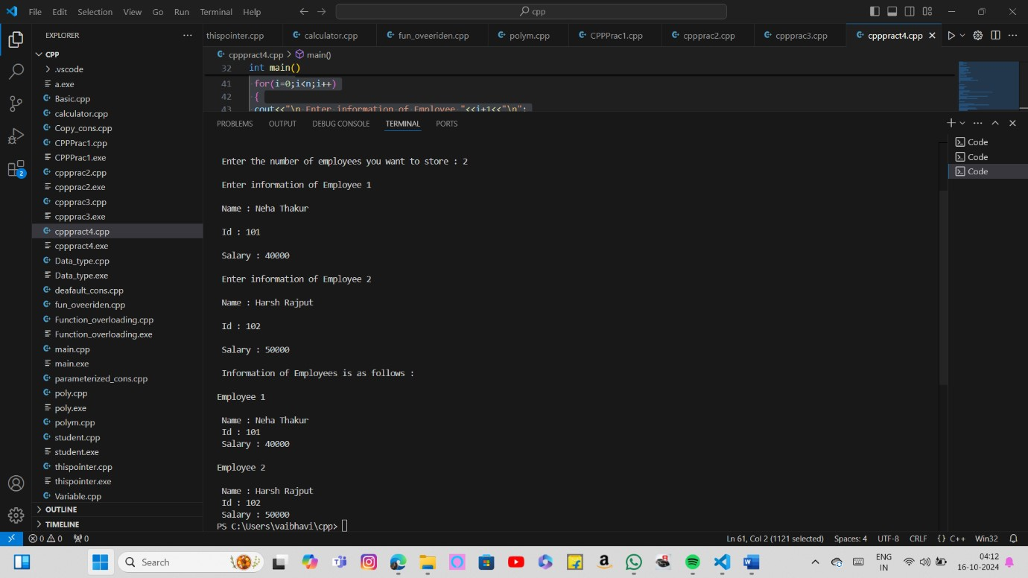

NAME: TEJASWINI SACHIN SHEWALE

ROLL NO.:37

SUBJECT:OOP

# Practical No.:05

Write a function template for selection sort that inputs, sorts and outputs an integer array and

a float array.

Code:

#include<iostream> using namespace std;

int n;

#define size 10 template<class T>

void sel(T A[size])

{ int i,j,min; T temp; for(i=0;i<n-1;i++)

{

min=i; for(j=i+1;j<n;j++)

{

if(A[j]<A[min]) min=j;

}

temp=A[i];

A[i]=A[min];

A[min]=temp;

}

cout<<"\nSorted array:"; for(i=0;i<n;i++)

{

cout<<" "<<A[i];

}

}

int main()

{ int A[size]; float B[size];

int i; int ch; do

{

cout<<"\n* * * * * SELECTION SORT SYSTEM * * * * *";

cout<<"\n--------------------MENU-----------------------"; cout<<"\n1. Integer Values"; cout<<"\n2. Float Values"; cout<<"\n3. Exit"; cout<<"\n\nEnter your choice : "; cin>>ch;

switch(ch)

{

case 1:

cout<<"\nEnter total no of int elements:";

cin>>n; cout<<"\nEnter int elements:";

for(i=0;i<n;i++)

{ cin>>A[i];

} sel(A); break; case 2:

cout<<"\nEnter total no of float elements:";

cin>>n; cout<<"\nEnter float elements:";

for(i=0;i<n;i++)

{

cin>>B[i];

} sel(B); break; case 3: exit(0);

}

}while(ch!=3); return 0;

}

Output:

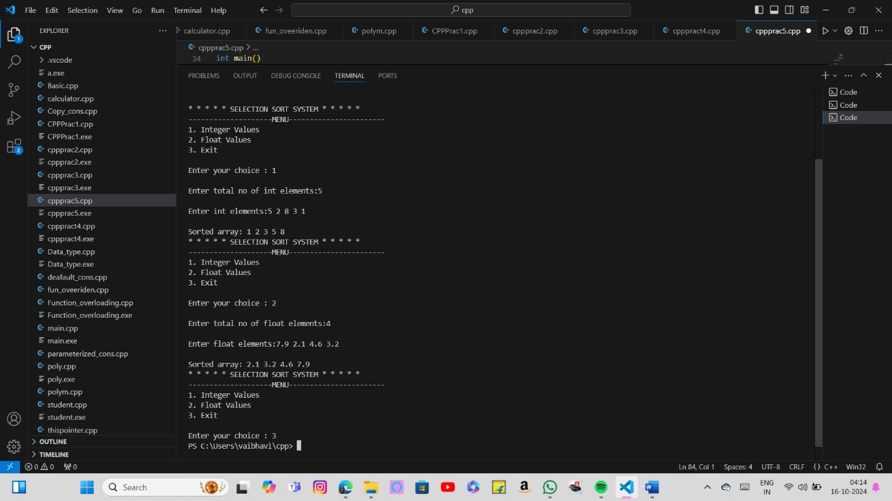

NAME: TEJASWINI SACHIN SHEWALE

ROLL NO.:37

SUBJECT:OOP

# Practical No.:06

Write C++ Program using STL for sorting and searching user defined records such as item records using vector container.

Code:

#include <iostream> //standard input output stream header file

#include <algorithm> //The STL algorithms are generic because they can operate on a variety of data structures

#include <vector> //The header file for the STL vector library is vector.

using namespace std; class Item // creating class Item

{

public:

char name[10];

int quantity; int cost; int code;

bool operator==(const Item& i1) //Boolean operators allow you to create more complex conditional statements

{

if(code==i1.code) //operator will return 1 if the comparison is true, or 0 if the comparison is false return 1; return 0;

}

bool operator<(const Item& i1)

{

if(code<i1.code) //operator will return 1 if the comparison is true, or 0 if the comparison is false return 1; return 0;

}

};

vector<Item> o1; void print(Item &i1); void display(); void insert(); void search(); void dlt();

bool compare(const Item &i1, const Item &i2)

{

//if (i1.name != i2.name) return i1.cost < i2.cost; return i1.cost < i2.cost;

}

int main()

{ int ch; do

{

cout<<"\n* * * * * Menu * * * * *"; cout<<"\n1.Insert"; cout<<"\n2.Display"; cout<<"\n3.Search"; cout<<"\n4.Sort"; cout<<"\n5.Delete"; cout<<"\n6.Exit"; cout<<"\nEnter your choice : "; cin>>ch;

switch(ch)

{

case 1: insert(); break; case 2: display(); break; case 3: search(); break; case 4:

sort(o1.begin(),o1.end(),compare); cout<<"\n\n Sorted on Cost : ";

display(); break; case 5: dlt(); break; case 6: exit(0);

}

}while(ch!=7); return 0;

}

void insert()

{

Item i1;

cout<<"\nEnter Item Name : "; cin>>i1.name; cout<<"\nEnter Item Quantity : "; cin>>i1.quantity; cout<<"\nEnter Item Cost : "; cin>>i1.cost; cout<<"\nEnter Item Code : "; cin>>i1.code; o1.push_back(i1);

}

void display()

{

for_each(o1.begin(),o1.end(),print);

}

void print(Item &i1)

{

cout<<"\n"; cout<<"\nItem Name : "<<i1.name; cout<<"\nItem Quantity : "<<i1.quantity; cout<<"\nItem Cost : "<<i1.cost; cout<<"\nItem Code : "<<i1.code; cout<<"\n\n";

}

void search()

{

vector<Item>::iterator p; Item i1; cout<<"\nEnter Item Code to search : "; cin>>i1.code; p=find(o1.begin(),o1.end(),i1); if(p==o1.end())

{

cout<<"\nNot found!!!";

}

else

{

cout<<"\nFound!!!";

}

} void dlt()

{

vector<Item>::iterator p; Item i1; cout<<"\nEnter Item Code to delete : "; cin>>i1.code; p=find(o1.begin(),o1.end(),i1); if(p==o1.end())

{

cout<<"\nNot found!!!";

}

else

{

o1.erase(p); cout<<"\nDeleted!!!";

}

}

Output:

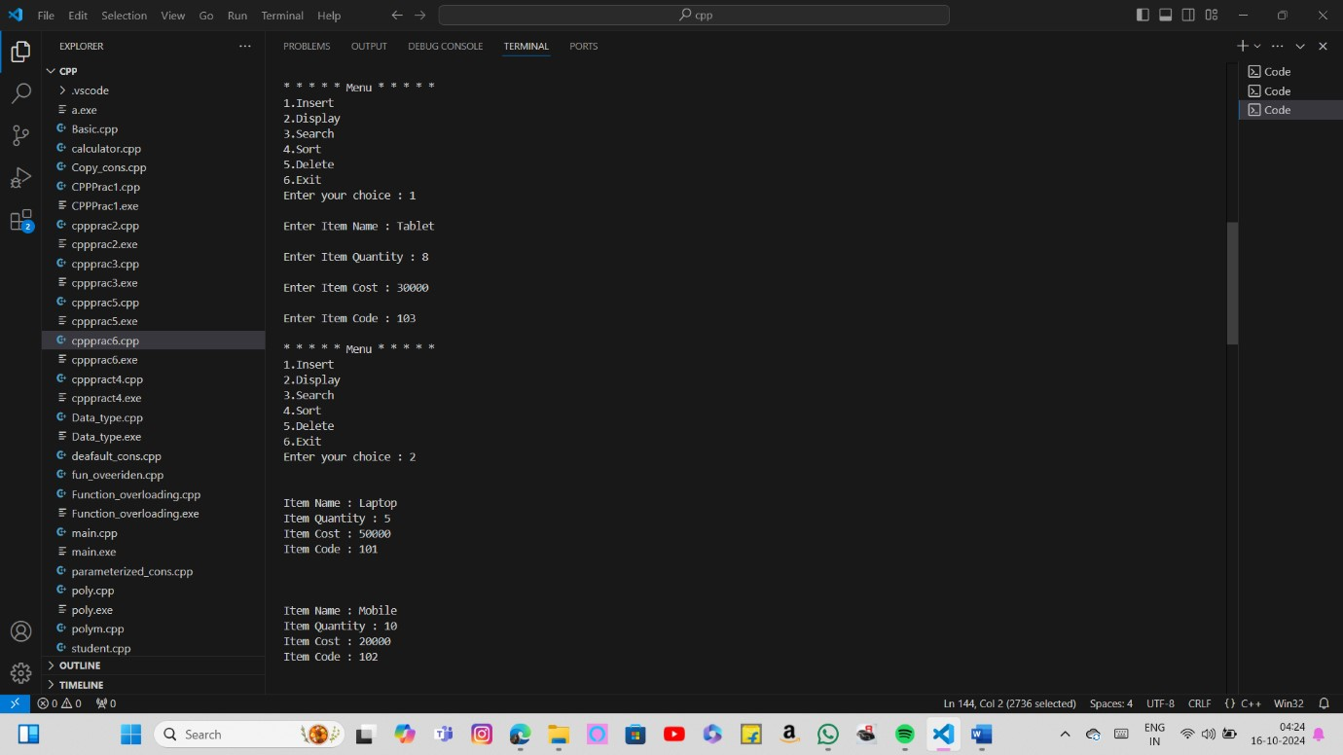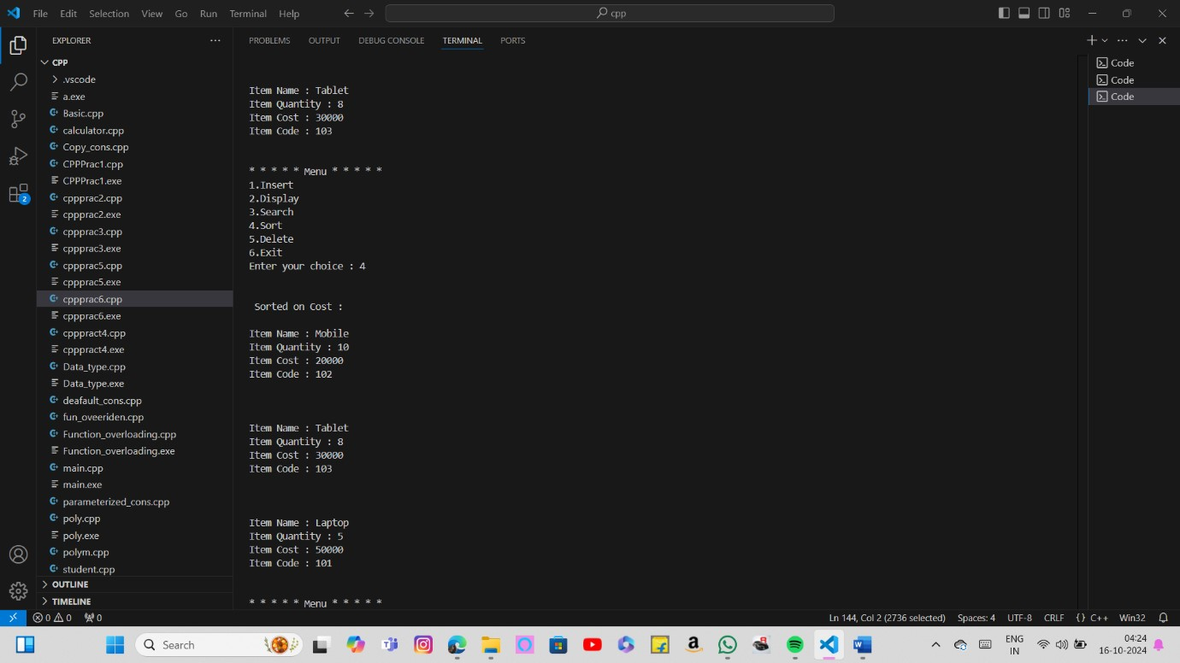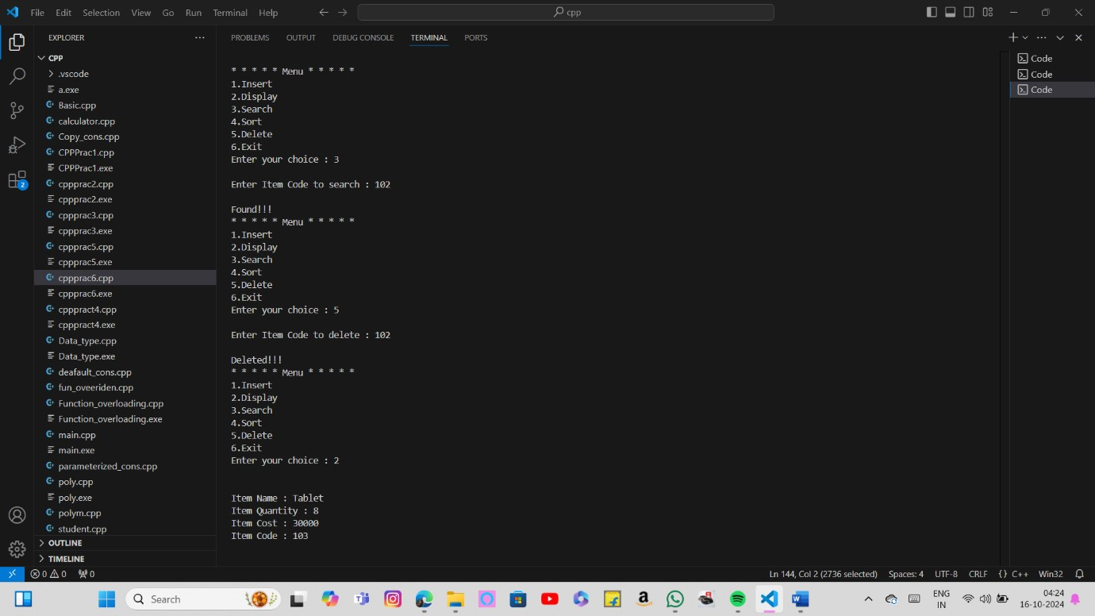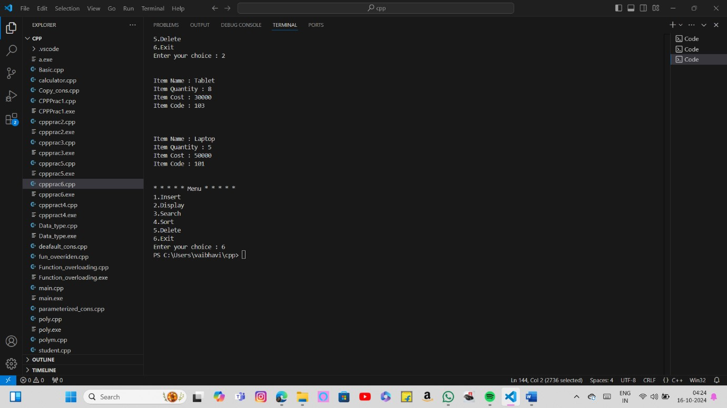

NAME: TEJASWINI SACHIN SHEWALE

ROLL NO.:37

SUBJECT:OOP

# Practical No.:07

Write a program in c++ to use map associative contaion the keys will be the names of states and the values will be the populations of the states. When the program runs, the user is prompted to type the name of a state. The program than looks in the map, using the state name as an index and returns the population of the state.

Code:

#include <iostream>

#include <map>

#include <string> #include <utility> using namespace std;

int main()

{

typedef map<string,int> mapType; mapType populationMap; populationMap.insert(pair<string, float>("Maharashtra", 125)); populationMap.insert(pair<string, float>("Uttar Pradesh", 225)); populationMap.insert(mapType::value_type("Bihar", 120)); populationMap.insert(mapType::value_type("West Bengal", 100)); populationMap.insert(make_pair("Madhya Pradesh", 90)); populationMap.insert(make_pair("Tamil Nadu", 80)); populationMap.insert(make_pair("Rajasthan", 78)); populationMap.insert(make_pair("Andhra Pradesh", 53)); populationMap.insert(make_pair("Odisha", 47)); populationMap.insert(make_pair("Kerala", 38)); populationMap.insert(make_pair("Telangana", 37)); populationMap.insert(make_pair("Assam", 35)); populationMap.insert(make_pair("Jharkhand", 38)); populationMap.insert(make_pair("Karnataka", 68)); populationMap.insert(make_pair("Gujarat", 70)); populationMap.insert(make_pair("Punjab", 31)); populationMap.insert(make_pair("Chhattisgarh", 30)); populationMap.insert(make_pair("Haryana", 29)); populationMap.insert(make_pair("UT Delhi", 19)); populationMap.insert(make_pair("UT Jammu and Kashmir", 14)); populationMap.insert(make_pair("Uttarakhand", 12)); populationMap.insert(make_pair("Himachal Pradesh", 8)); populationMap.insert(make_pair("Tripura", 04)); populationMap.insert(make_pair("Meghalaya", 4)); populationMap.insert(make_pair("Manipur[", 3)); populationMap.insert(make_pair("Nagaland", 2)); populationMap.insert(make_pair("Goa", 2)); populationMap.insert(make_pair("Arunachal Pradesh", 2)); populationMap.insert(make_pair("UT Puducherry", 2)); populationMap.insert(make_pair("Mizoram", 1)); populationMap.insert(make_pair("UT Chandigarh", 1)); populationMap.insert(make_pair("Sikkim", 1)); populationMap.insert(make_pair("UT Dadra and Nagar Haveli and Daman and Diu", 1)); populationMap.insert(make_pair("UT Andaman and Nicobar Islands", 1)); populationMap.insert(make_pair("UT Lakshadweep", 0.0003)); populationMap.insert(make_pair("UT Ladakh", 0.00006)); mapType::iterator iter = --populationMap.end(); populationMap.erase(iter); cout << "Total state and UT of India with Size of populationMap: " << populationMap.size() << '\n'; for (iter = populationMap.begin(); iter != populationMap.end(); ++iter)

{

cout << iter->first <<":" << iter->second << " million\n";

}

char c;

do

{

string state;

cout<<"\nEnter that state you want to know the population of: "; cin>>state; iter = populationMap.find(state); if( iter != populationMap.end() ) cout << state <<"'s populations is " << iter->second << " million\n"; else

cout << "State is not in populationMap" << '\n'; cout<<"Do you wish to continue?(y/n):";

cin>>c;

}while(c=='y'||c=='Y'); populationMap.clear();

return 0;

}

Output:

